Experiment: 6
5G NR Frame Structure Analysis with Different Subcarrier Spacing
Aim
To analyze the 5G NR frame structure by studying the effect of different subcarrier spacings, slot durations, and OFDM symbols using MATLAB.

Objective – 1
Analyze the standard subcarrier spacing (SCS) values defined in the 5G NR numerology using MATLAB. Compare the relationship between the numerology index (μ) and subcarrier spacing to understand the flexible bandwidth allocation employed in 5G communication systems.
Procedure
• Define the supported 5G NR subcarrier spacing values.
• Display the values using MATLAB.
• Plot the subcarrier spacing for different numerologies.
Objective – 1: Analyze Different Subcarrier Spacing Values
MATLAB Program
clc;
clear;
close all;
scs = [15 30 60 120 240]; % Subcarrier Spacing (kHz)
mu = 0:4; % Numerology Index
bar(scs)
grid on
set(gca,'XTick',1:5)
set(gca,'XTickLabel',mu)
xlabel('Numerology Index (\mu)')
ylabel('Subcarrier Spacing (kHz)')
title('5G NR Subcarrier Spacing for Different Numerologies')
Expected Output
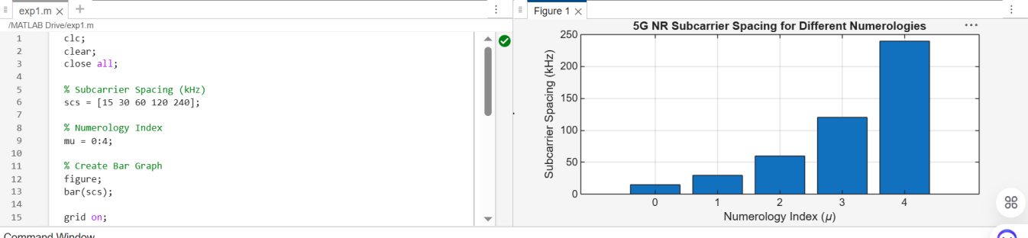
Objective – 2 Compare Slot Duration
Analyze the variation in slot duration corresponding to different 5G NR subcarrier spacing values using MATLAB. Compare the inverse relationship between subcarrier spacing and slot duration to understand how flexible numerology enables low-latency communication in 5G networks.
Procedure
• Define the slot duration corresponding to each subcarrier spacing.
• Plot slot duration versus subcarrier spacing.
• Observe the inverse relationship.
MATLAB Program
clear;
close all;
scs = [15 30 60 120 240]; % Subcarrier Spacing (kHz) slot = [1 0.5 0.25 0.125 0.0625]; % Slot Duration (ms)
plot(scs, slot, 'o-', 'LineWidth', 2)
grid on
xlabel('Subcarrier Spacing (kHz)')
ylabel('Slot Duration (ms)')
title('5G NR Slot Duration for Different Subcarrier Spacing')
Expected Output
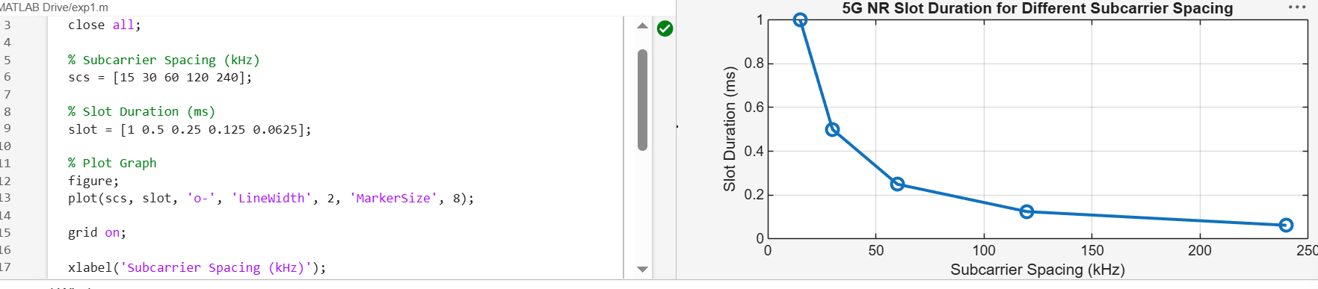
Objective – 3 Study the Number of OFDM Symbols
Analyze the number of OFDM symbols present in a 5G NR slot for different numerology configurations using MATLAB. Observe that, under the normal cyclic prefix, each slot consistently contains 14 OFDM symbols irrespective of the subcarrier spacing.
Procedure
• Define the number of OFDM symbols in a slot.
• Plot the OFDM symbols for different numerologies.
• Observe that the number of symbols remains constant.
MATLAB Program
clc;
clear;
close all;
scs = [15 30 60 120 240]; % Subcarrier Spacing (kHz)
symbols = [14 14 14 14 14]; % OFDM Symbols per Slot
figure
bar(scs, symbols)
grid on
xlabel('Subcarrier Spacing (kHz)')
ylabel('Number of OFDM Symbols')
title('OFDM Symbols per Slot for Different Subcarrier Spacing')
ylim([0 16])
Expected Output
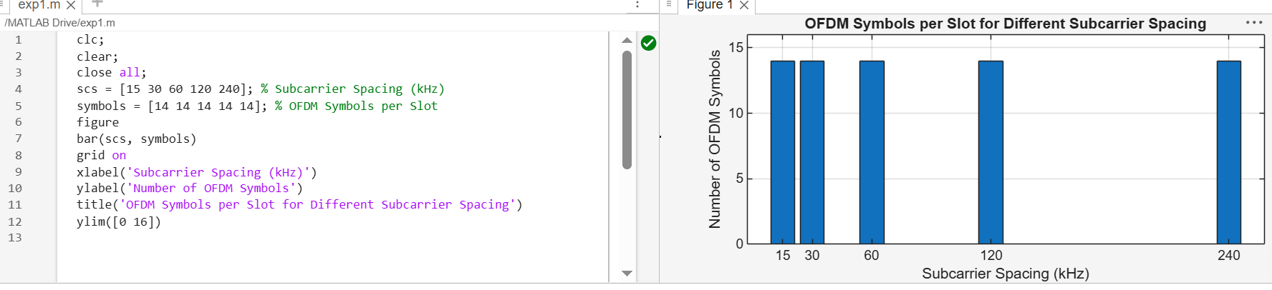
Result
The MATLAB analysis successfully demonstrated the flexible numerology of 5G NR. The results showed that increasing the subcarrier spacing decreases the slot duration while maintaining a constant number of OFDM symbols per slot under the normal cyclic prefix configuration.

